Standalone-Script

TSC New Job Directory Request

Migration Plan

Department of the Interior  
Email & Collaboration Solution

|  |  |
| --- | --- |
| Submitted to  U.S. Department of the Interior  Bureau of Reclamation (BOR)  Lee Jacobs  [ljacobs@usbr.gov](mailto:ljacobs@usbr.gov)  Submitted [October, 22, 2019] | Submitted by  The Planet Team  Antonio Sandoval  Program Manager  Planet Technologies  [asandoval@go-planet.com](mailto:asandoval@go-planet.com)  [antonio_sandoval@ios.doi.gov](mailto:antonio_sandoval@ios.doi.gov)  Brian Vos  Development Lead  Planet Technologies  [bvos@go-planet.com](mailto:bvos@go-planet.com)  [brian_vos@ios.doi.gov](mailto:brian_vos@ios.doi.gov) |

*All information contained in this document is Planet Technologies, Inc. proprietary and is limited to distribution between Planet Technologies, Inc., its partners, and Department of the Interior.*

**

Contents

Document History 2

TSC Directory Access Request 3

Introduction 3

Existing solution description 3

Other Discoveries 4

Data Storage 4

Requirements 6

Script Steps: 6

Functional Requirements: 7

Data Requirements: 10

Permissions: 10

Screenshots: 10

Level of Effort 19

Proposed solution: 19

Roles required: 20

Effort and tasks: 20

Schedule Impacts 21

Acceptable downtime: 21

Drive & Mail Migration Consideration 21

Solution Sign – Off 21

Requirements 22

Testing 22

Release 22

# Document History

|  |  |  |  |  |  |
| --- | --- | --- | --- | --- | --- |
| Version | Implemented By | Revision Date | Approved By | Approval Date | Reason |
| 0.25 | The Planet Team | 10/22/2019 |  |  | Drafted |
| .5 | The Planet Team and DOI | 10/25/2019 | Lee Jacobs | 10/25/2019 | Requirements Defined |
| .75 | The Planet Team and DOI |  |  |  |  |

# TSC Directory Access Request

## Introduction

This document serves as the requirements to recreate the existing Google script with Microsoft products. Please note that we are only recreating existing features of the Google Script and we will not be adding additional functionality or changing how the script operated. In the rare circumstance that we are not fully able to recreate the complete functionality of the Script in Microsoft, we will document the gap and provide alternatives for considerations.

## Existing solution description

Form to request folder permission access to network shares. Simple interface provides ability to select appropriate users and access to submit new request.

1. The TSC form [New Job Request Form](https://docs.google.com/forms/d/e/1FAIpQLSeiSCZdyPYZewBUOCMf_E4-ldg6YDblU8FxAO_RIio7RawPiQ/viewform?pli=1) is updated weekly according to a script using the Staff Sheet and Features Sheet

CMC addition: From Lee’s 10/23 emailHere is the link to the form submissions so that the file management team can keep track of the requests. <https://docs.google.com/spreadsheets/d/1gAv9EepR-NtH8Ckr2LdvBJLCdnbORxmY_vh5KIRX1lw/edit#gid=248757902>

1. Staff Sheet: TSC Users and AD Group Lists is manually updated weekly (or more frequently) by reporting group memberships from Active Directory (a Java program accomplishes this for a simple copy/paste into the Sheet). (There doesn't seem to be a Google API we can use to do this directly.)
2. Features Sheet: Features Sheet is manually updated every time we add, remove, or modify a feature. Changes are infrequent (about once per month).

TSC, in accordance with the IRO SLA for directory permissions, needs a way to request new directories and tell us what members need access to those directories.

The directory structure is large and complex, and therefore a master sheet of features must be used to keep control on directory creation and maintenance.

TSC Staff is always in flux with new and removed employees, including detail and intern staff.

Trying to keep the form updated manually would be burdensome, at best.

Users relying on the solution:

All of the Technical Service Center (approximately 551 total staff) plus all bureau staff that need to request access.

### Other Discoveries

* CSV external dependency with Active Directory user detail
* CSV file generated outside of Google Application
* CSV file out of scope
* CSV file hosted at <http://bordams.bor.doi.net/dams/TSC/AuditGroups.csv>
* Email notification to requestor for simple workflow
* Cascades second request downstream to IT team (manually)
* Sheet tracks request downstream IT status

### Data Storage

Below URLs to current solution inventory data connection used to populate form interface.

|  |  |
| --- | --- |
| Purpose | URL |
| User Choices | <https://docs.google.com/spreadsheets/d/1XbyPwXEYgmK_SrJ0keTD5FVVHH37LXL_1mdmpxjElXA/edit#gid=1778506905>  Using the tab: “TSCUsers Master List”  Because the sheet should be updated (manually) from the CSV file. The CSV file is auto-generated twice a week from Active Directory LDAP queries. Monday/Thursday 2AM MDT.  The sheet is used by the script to update staff names in the form.  The tab 'Group Membership' is also used to get a listing of groups, but this could as easily be hardcoded. |
| User Choices | <https://docs.google.com/spreadsheets/d/1rgKgNo0XBm43eUZ4QUMmohONvyV5SSg0oS74ehQRjsc/edit#gid=382884305>  Tab “Master Facility List” is updated whenever our facilities/features change.  The sheet is used by the script to update the features in the form (broken out by region) |
| Form Interface | <https://docs.google.com/forms/d/1zvb6y7e_t04SRqIVhGox5iCqj_H2461U9QrGLUNI3UQ/edit>  The form must be updated to keep up with the changes to staff (frequently changing) and features (infrequently changing). |
| Form Responses | <https://docs.google.com/spreadsheets/d/1gAv9EepR-NtH8Ckr2LdvBJLCdnbORxmY_vh5KIRX1lw/edit#gid=248757902>  File management team can keep track of the requests.   * Columns A through Z are the contents of the form submissions. * Column AA:  This is a formula to capture only the emails from column Z for ease in copy-paste to our IT Help Desk (they only want the emails of users to build AD [Active Directory] groups from).  The formula is: =ArrayFormula(If(isblank($X$9:$X),"",REGEXREPLACE($X$9:$X&", "&$Y$9:$Y&", "&$Z$9:$Z,"\w+? ?-?'?\w+, \w+? ?\w+\.? \(|\) \w+\/\w+\/\w+,?|\) \w+\/\w+,?|\) \w+,?"," "))) * Column AB:  This is the ticket number we manually populate after we submit the ticket to IT to create and populate the AD group. This way we know we have 'handled' the ticket and it's now in the hands of our IT help desk. * Column AC:  This is the manually populated date that we entered the ticket (from column AB) * Column AD:  This is the date that we receive notice from our IT help desk that the AD group has been created, populated, and permissions given to the directory we created (the directory we created is only recorded in the ticket, and not in this sheet - but it is based on the template, feature, and year). * Column AE: We will use this column to record a 'closed' job - we might not use this as we are testing it right now. * Column AF:  Comments about the job request to inform other team members of what is happening to the ticket or other pertinent information. |
| Active Directory Users | <http://bordams.bor.doi.net/dams/TSC/AuditGroups.csv>  External data source with user listing. |
| Shared Mailbox | [drotscfilemgmt@usbr.gov](mailto:drotscfilemgmt@usbr.gov) |

## Requirements

### Script Steps:

1. User fills out the [TSC New Job Directory Request](https://docs.google.com/forms/d/e/1FAIpQLSejvBlmP2bnoz2IJiH9UjQzjtmcMarzXHOYRBnCRLMGfHiugw/viewform) and submits. Sections and Flow of the form:
   1. Provide “Select whether this Job is for a BOR Region, another Agency”
   2. Provide “Which BOR DO Job are you working on?”
   3. Provide “Did you find what you were looking for?”
   4. Provide “Enter Job Information”
   5. Provide “Starting (calendar) year of Job”
   6. Provide “Type of template”
   7. Provide “Who is the Project Manager for this Job?”
   8. Select “Select team members” with over 500 checkbox selection. Scroll many pages.
2. A new record is added to the [TSC (Responses) sheet](https://docs.google.com/spreadsheets/d/1DTB7MBwP8Xa3Anc4vzSM1oAP0kP3DWk21zWZKl3tZqo/edit?usp=sharing)
3. Email sent to end users confirming request.
4. TCS team opens ticket with technical team to fulfill the creation.
5. When access granted, mark item complete
6. Email sent to original TCS requestor, indicating complete, and ready for access.

### Functional Requirements:

Form Requirements

1. Form Header Image:



1. Form Title: New Job Directory Request
2. Form Instructions:
   1. NOTE: if you are not the TSC Project Manager for this job then that individual will be contacted to obtain their permission to create the new job directory and to confirm that all the information entered here is correct.
   2. Your email address (jeffrey_jones@ios.doi.gov) will be recorded when you submit this form. Not you? Switch account
3. GENERAL INFORMATION Section fields
   1. Select whether this Job is for a BOR Region, another Agency:
      1. Type: Choices
      2. Required: Yes
      3. BOR DO (includes Research & Programs)
      4. BOR GP
      5. BOR LC
      6. BOR MP
      7. BOR PN
      8. BOR UC
      9. Non-BOR
   2. Which BOR DO Job are you working on?
      1. Type: Check all BOR DO items that apply.
      2. Required: Yes
      3. Asset Management Guidance (Program)
      4. DFC Building 67 ()
      5. Dam Performance During Seismic Loading (Research)
      6. Dam Safety Technology Development (Research)
      7. FBMS Guidance (Program)
      8. Information Sharing Environment (Program)
      9. Manuals and Standards (Program)
      10. Planning Guidance (Program)
      11. Prize Competitions (Research)
      12. Science and Technology (Research)
      13. Strategic Energy Initiatives (Program)
      14. Technology Transfer (Research)
      15. WaterSMART ()
   3. Did you find what you were looking for?
      1. Type: Choice
      2. Required: Yes
      3. Yes, found it! (Will take you to Job Information)
      4. No, I need to tell you more about my Job
      5. No, Let me try a different Region/Agency
   4. Starting (calendar) year of Job: *
      1. Type: Text
      2. Required: Yes
      3. Validate: 4 digit year
   5. Type of template
      1. Type: Choice
      2. Required: Yes
      3. DS-CR (Dam Safety, Comprehensive Review)
      4. DS-IE (Dam Safety, Issue Evaluation)
      5. DS-PFR (Dam Safety, Periodic Facility Review)
      6. DS-SI (Dam Safety, Specific Incident)
      7. DS-TRT (Dam Safety, Technical Response Team)
      8. EBC (Environmental, Biological, Cultural)
      9. OMI (Operations, Maintenance, Inspection)
      10. PDC (Planning, Design, Construction) includes all Dam Safety Corrective Action Studies
      11. PRG (Programs or Research)
      12. SMMP (Strong Motion Monitoring Program)
   6. Job Description - what does this Job accomplish? This description will be used as the name of the folder. Keep it short. Do not use acronyms or abbreviations. *
      1. Type: Text
      2. Required: Yes
   7. Who is the Project Manager for this Job? *
      1. Type: Choice Person
      2. Required: Yes
   8. Who is the Project Manager's supervisor? *
      1. Type: Choice Person
      2. Required: Yes
   9. Select team members
      1. Which members need write access? *
   10. Send me a copy of my responses.
       1. Type: Yes/No

Google Sheets Template:

|  |  |  |  |
| --- | --- | --- | --- |
| Sheets Section | Sheets Field | Row Coloring | Form Mapping |
| TSC Users Master List | Name |  | Manually Entered |
| Email | Manually Entered |
| Group(S) | Manually Entered |
|  |  |
| Group Memberships | Group |  | Manually Entered |
| AD Name | Manually Entered |
| Includes | Manually Entered |
|  |  |
| Individuals | Requestor |  | Manually Entered |
| Folder Requested | Manually Entered |
| Ticket # | Manually Entered |
| Date Requested |  |
| Features | Region (USACE Div) |  | Manually Entered |
| Reclamation Feature Represented (If required) | Manually Entered |
| Feature Name | Manually Entered |
| Associated Project | Manually Entered |
| Project Number | Manually Entered |
| Project Nickname (Don't Use) | Manually Entered |
| Division (BIA Tribe, NPS Park, FWS Refuge) | Manually Entered |
| "Division | Manually Entered |
| Nickname" | Manually Entered |
| Unit | Manually Entered |
| Unit Nickname | Manually Entered |
| Parent Site/Location | Manually Entered |
| State | Manually Entered |
| Watercourse | Manually Entered |
| Notes/Comments | Manually Entered |
| Duplicates | Manually Entered |
| ID | Manually Entered |

### Data Requirements:

On 10/18, we confirmed that the product stakeholders can make a copy of the existing data if necessary. We will attempt to migrate the data and the stakeholder should make a copy as a contingency. There are no external data sources.

### Permissions:

The form is available to anyone on the DOI network and can be filled out by any DOI user. The Form configuration is editable by the following users: Lee Jacobs. The Google Sheet is read only to anyone on the DOI network and editable by Lee Jacobs. We will attempt to include the same permissions.

### Screenshots:

Form:

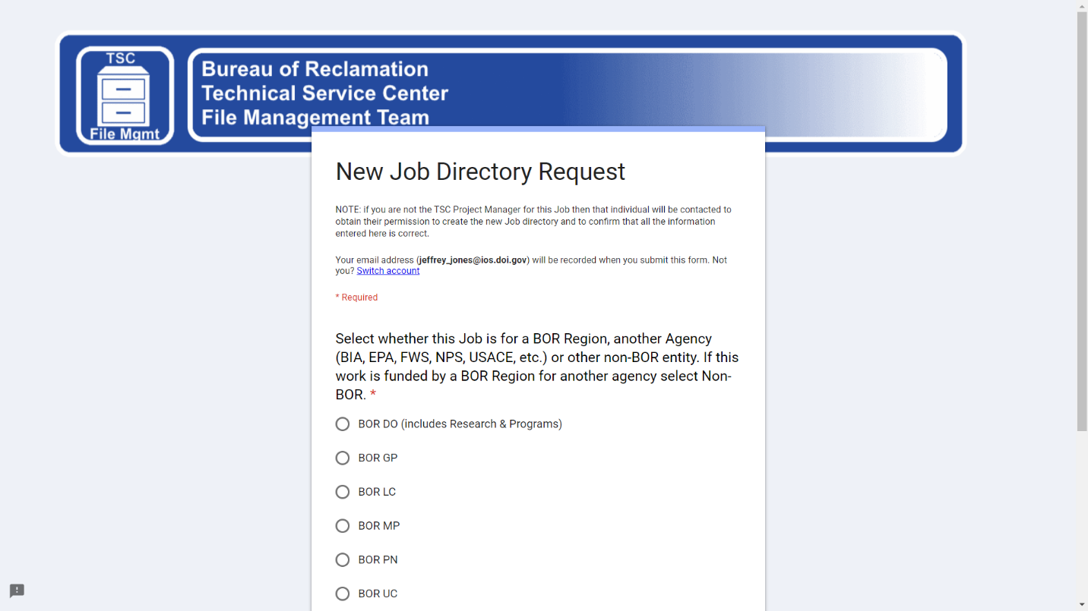

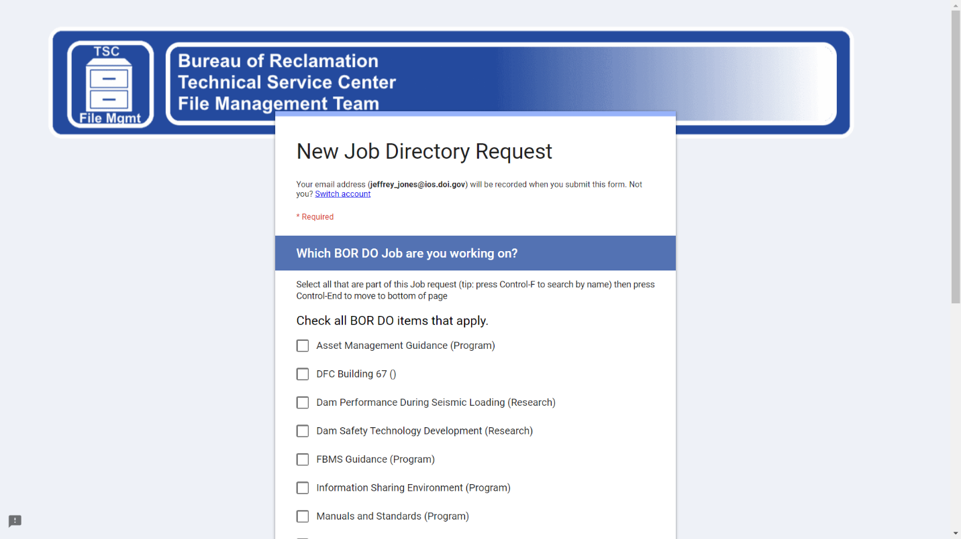

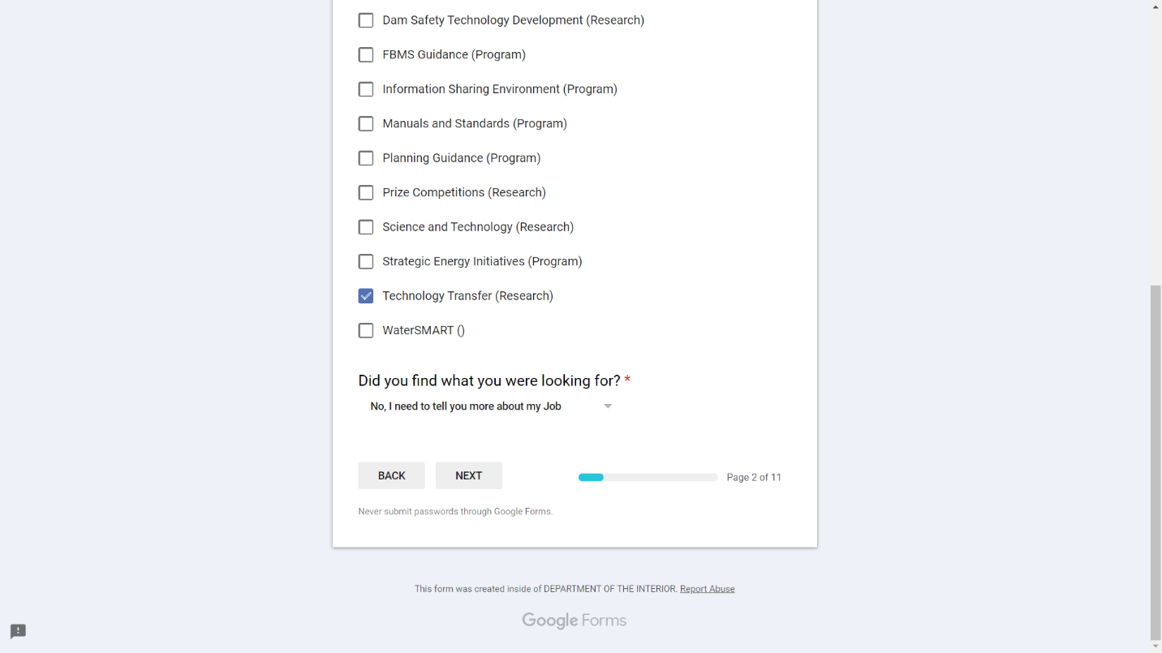

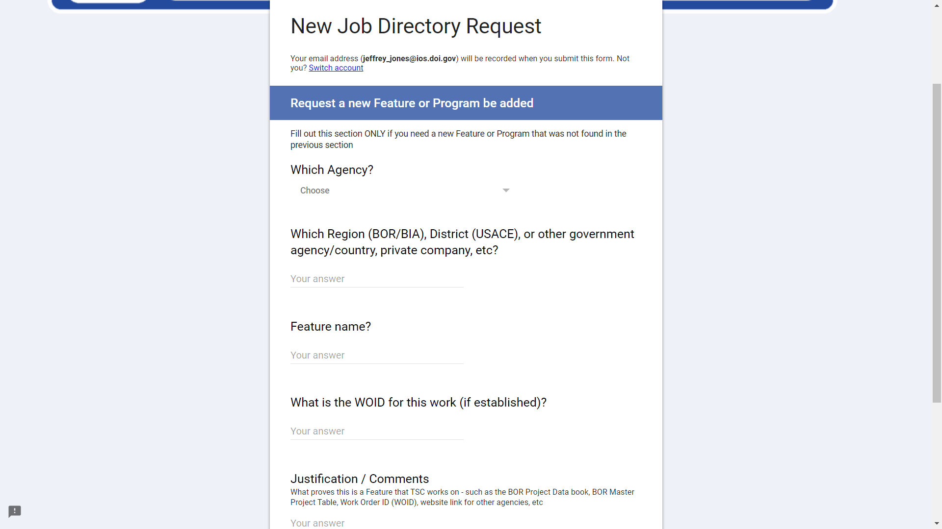

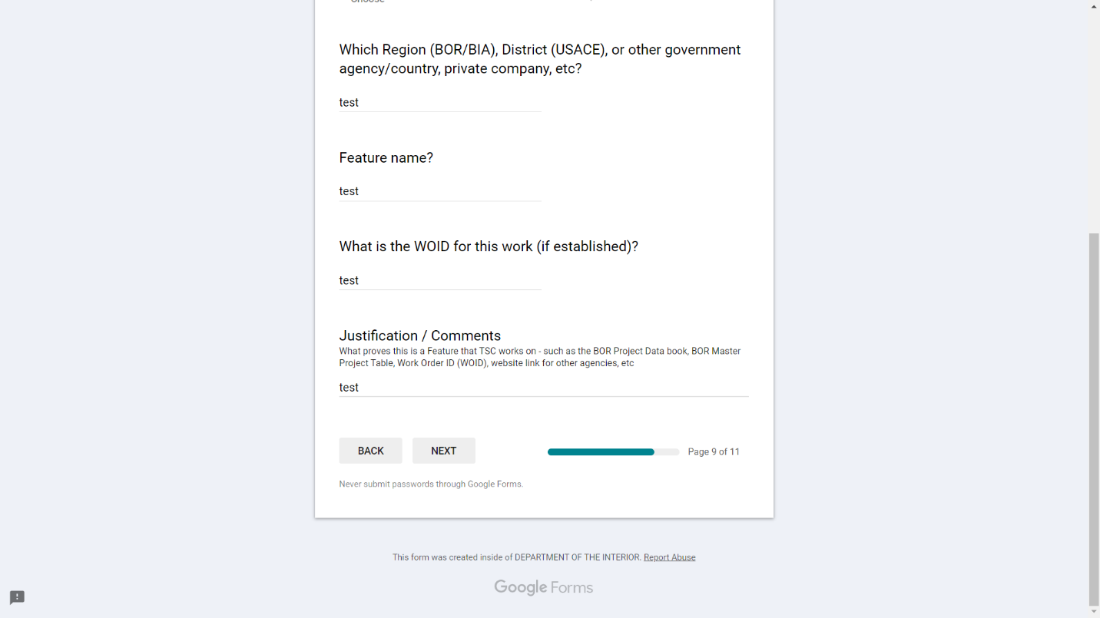

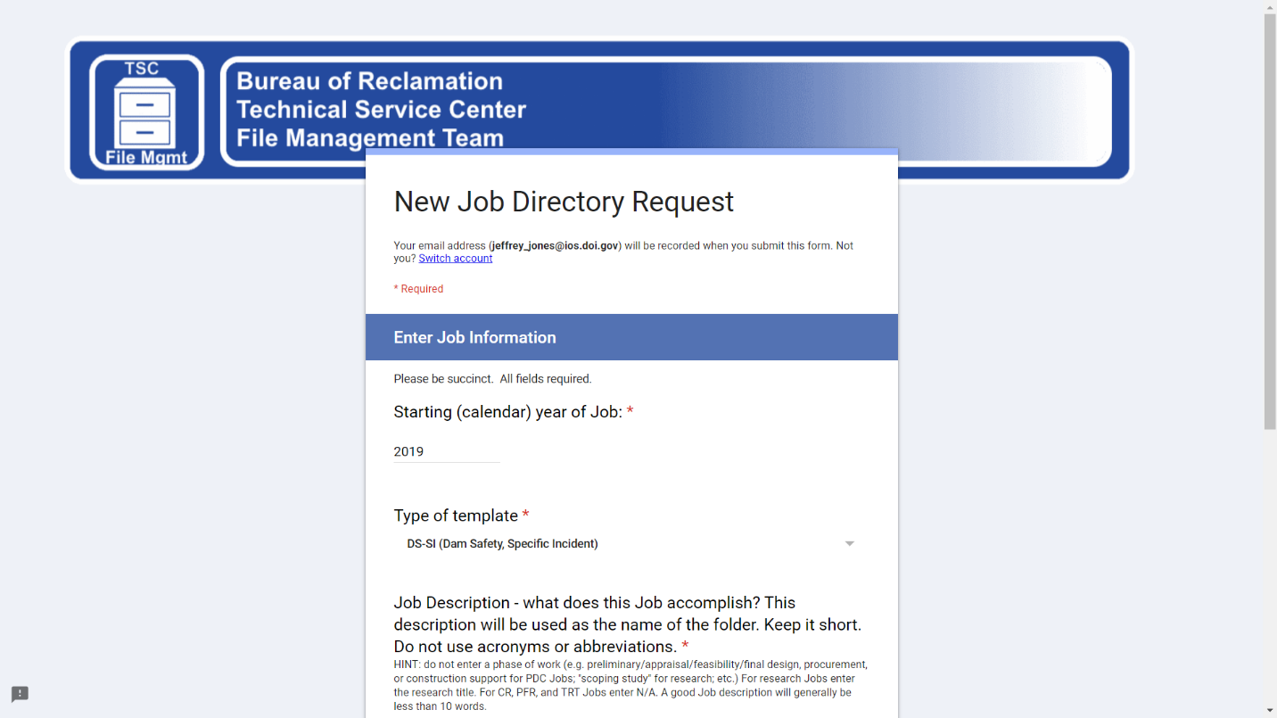

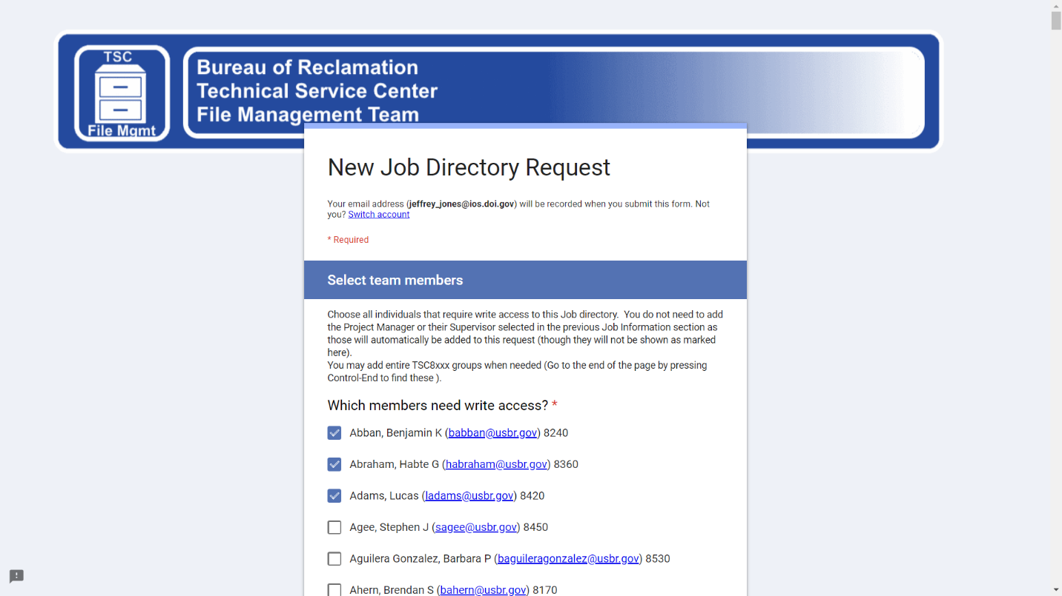

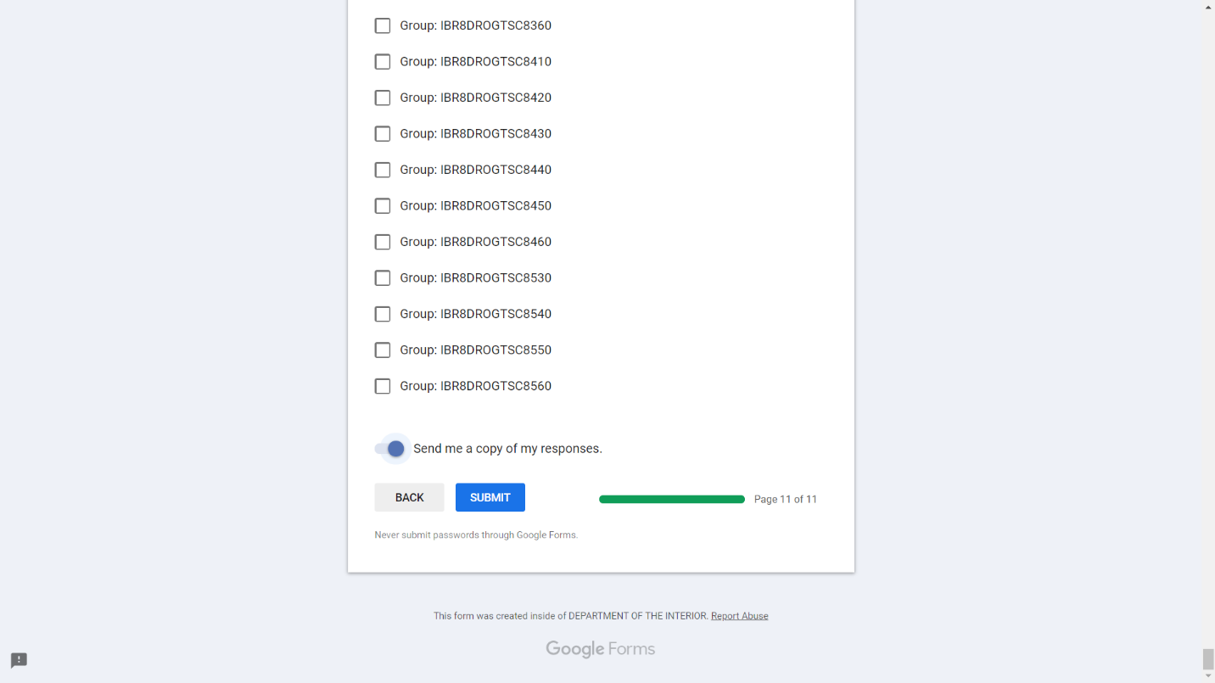

TSC New Job Directory Request (Responses) Sheet:

Here is the link to the form submissions so that the file management team can keep track of the requests. <https://docs.google.com/spreadsheets/d/1gAv9EepR-NtH8Ckr2LdvBJLCdnbORxmY_vh5KIRX1lw/edit#gid=248757902>

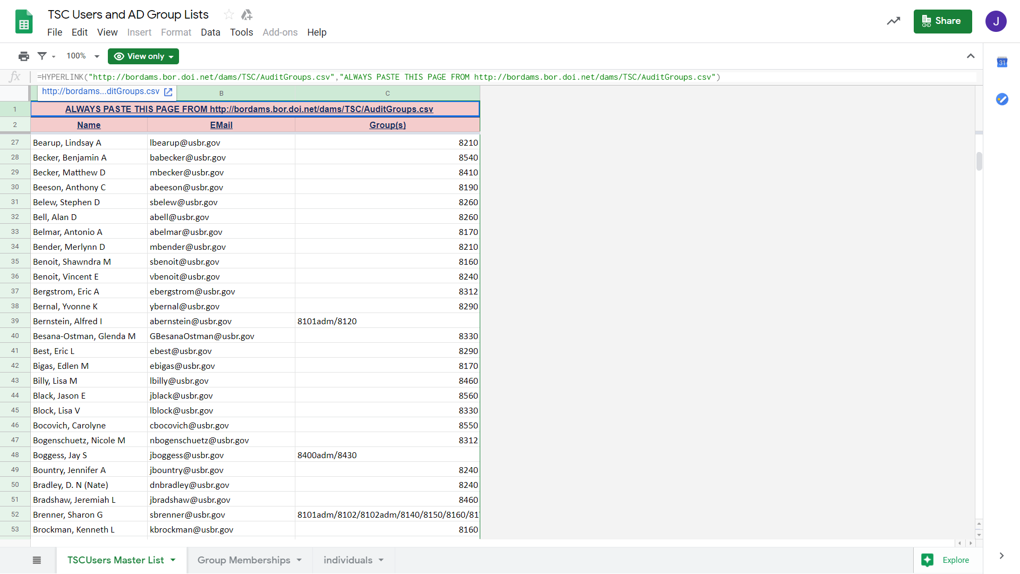

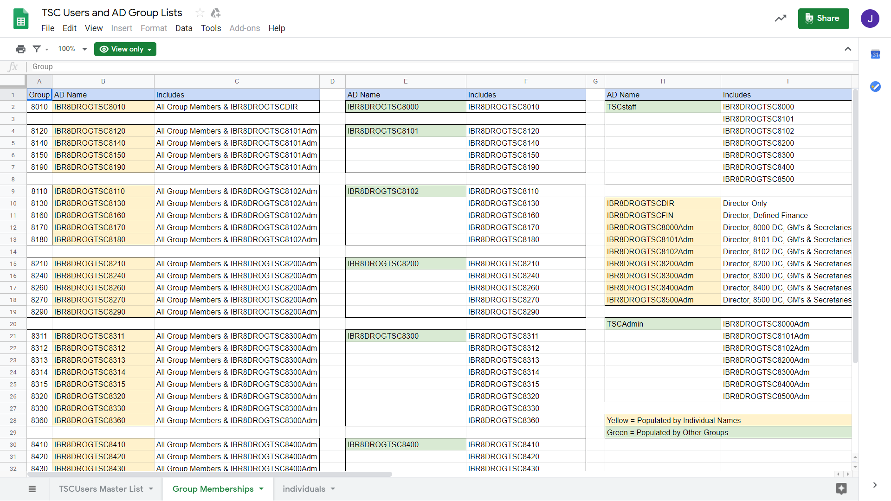

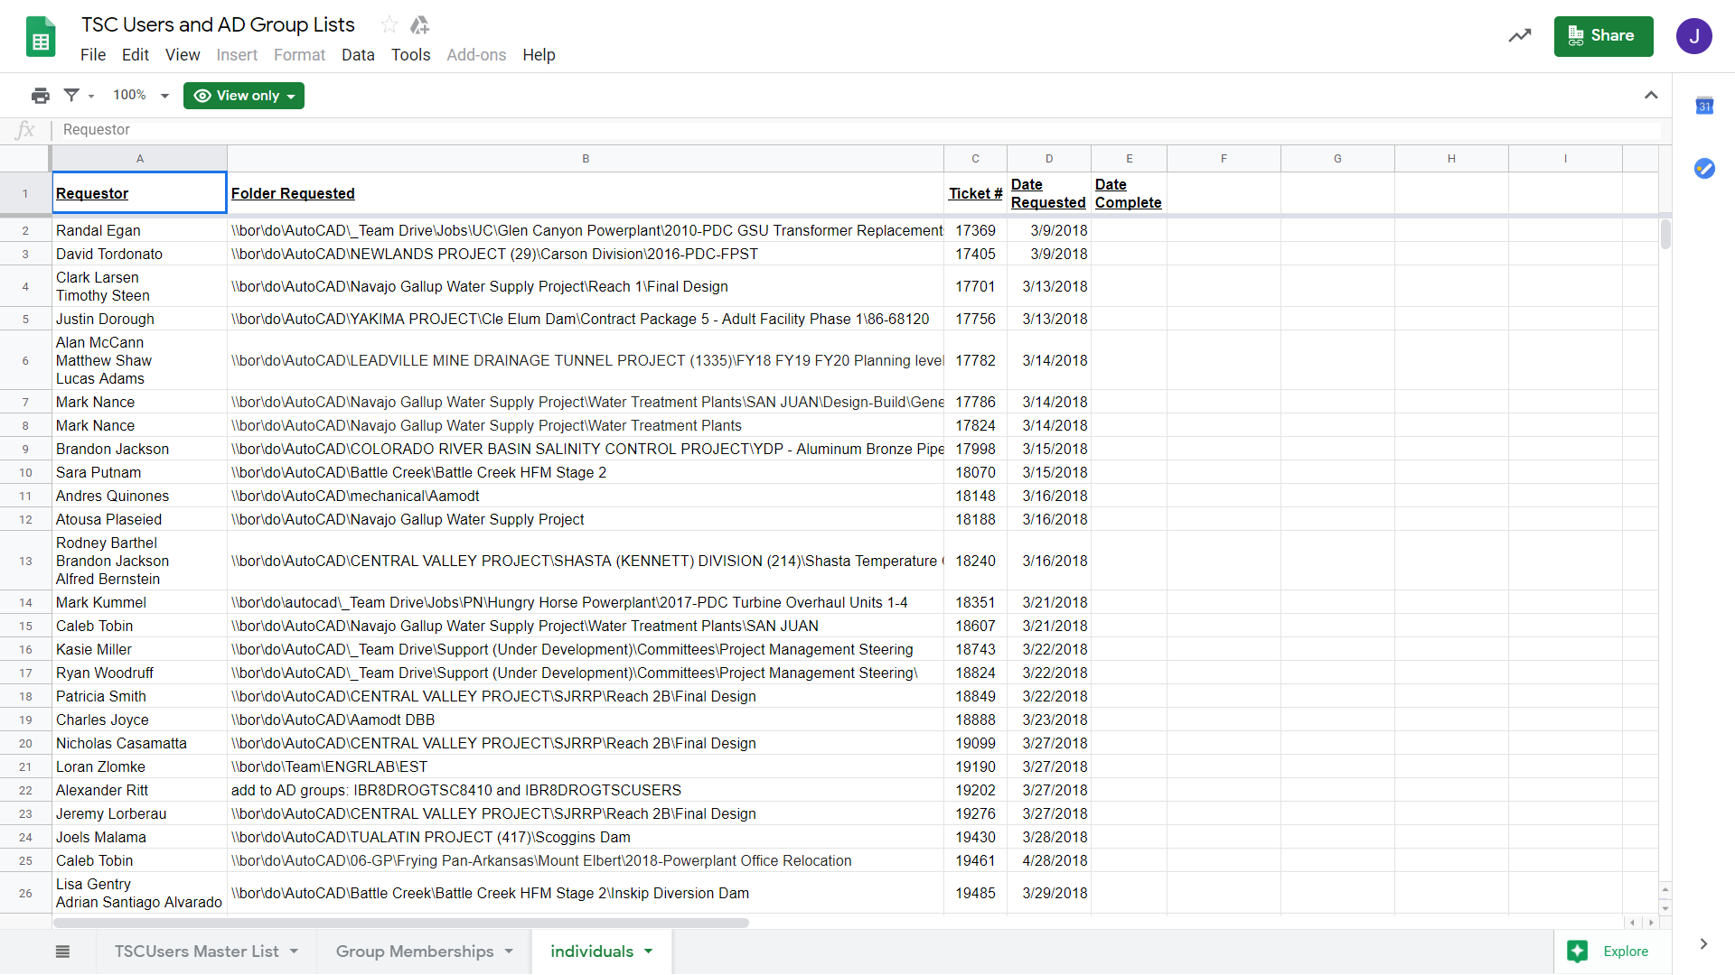

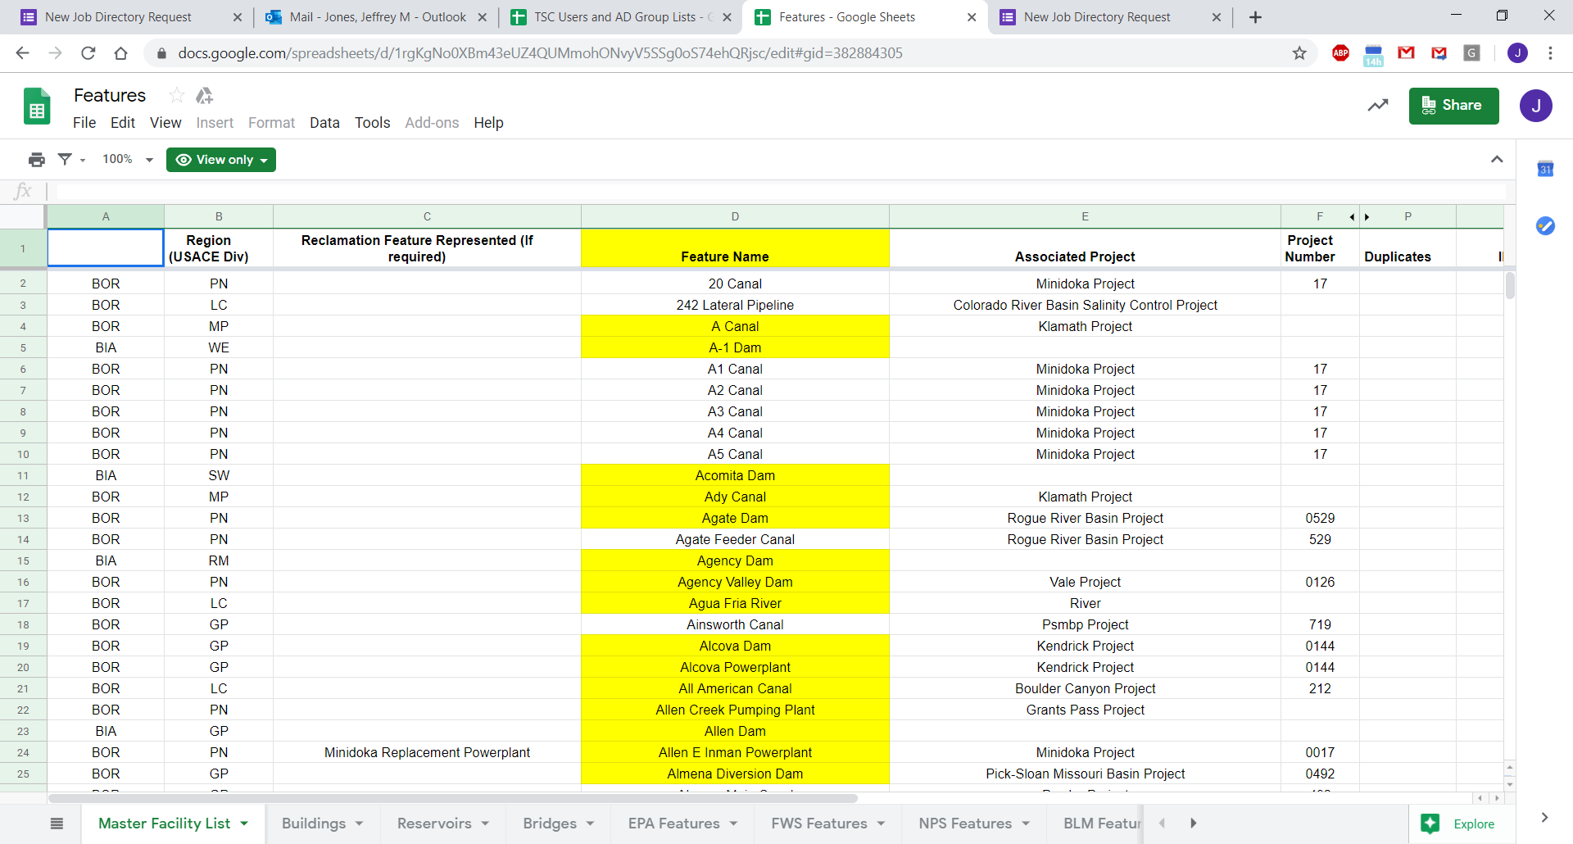

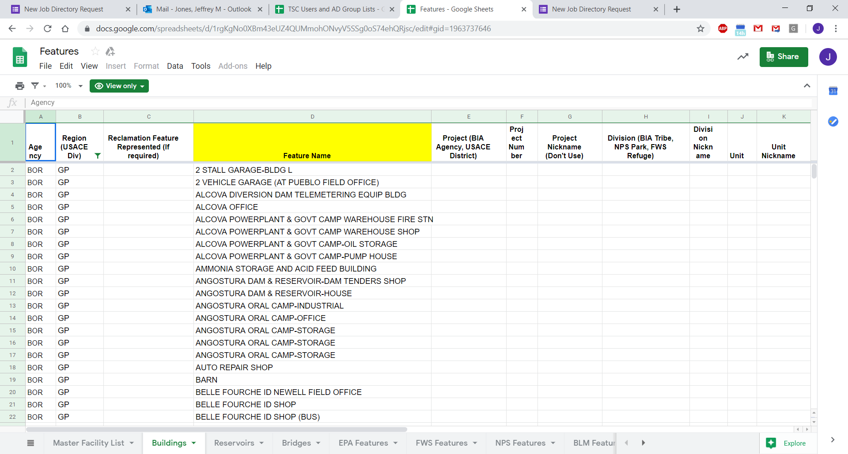

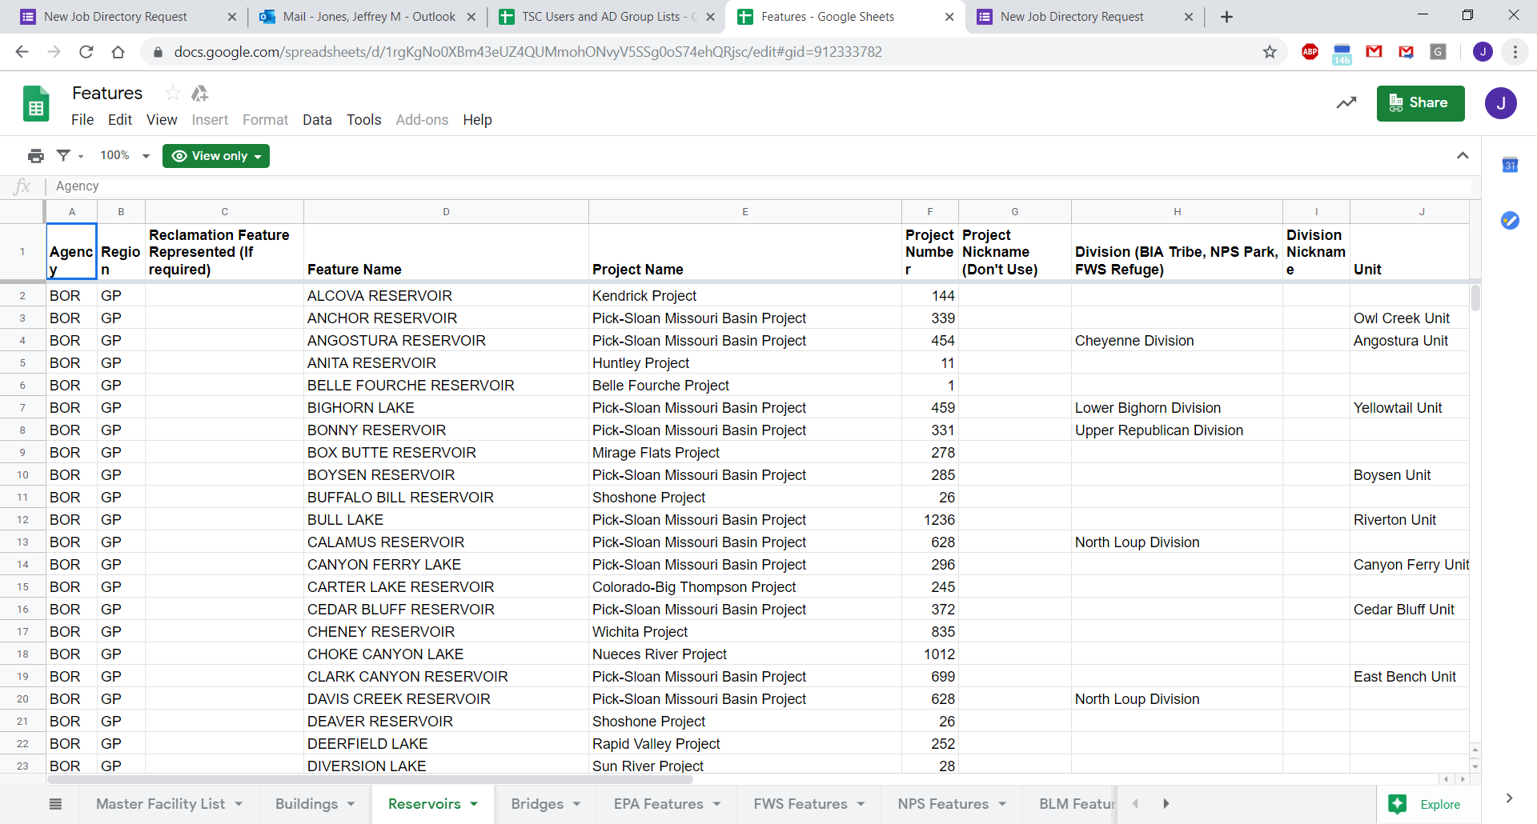

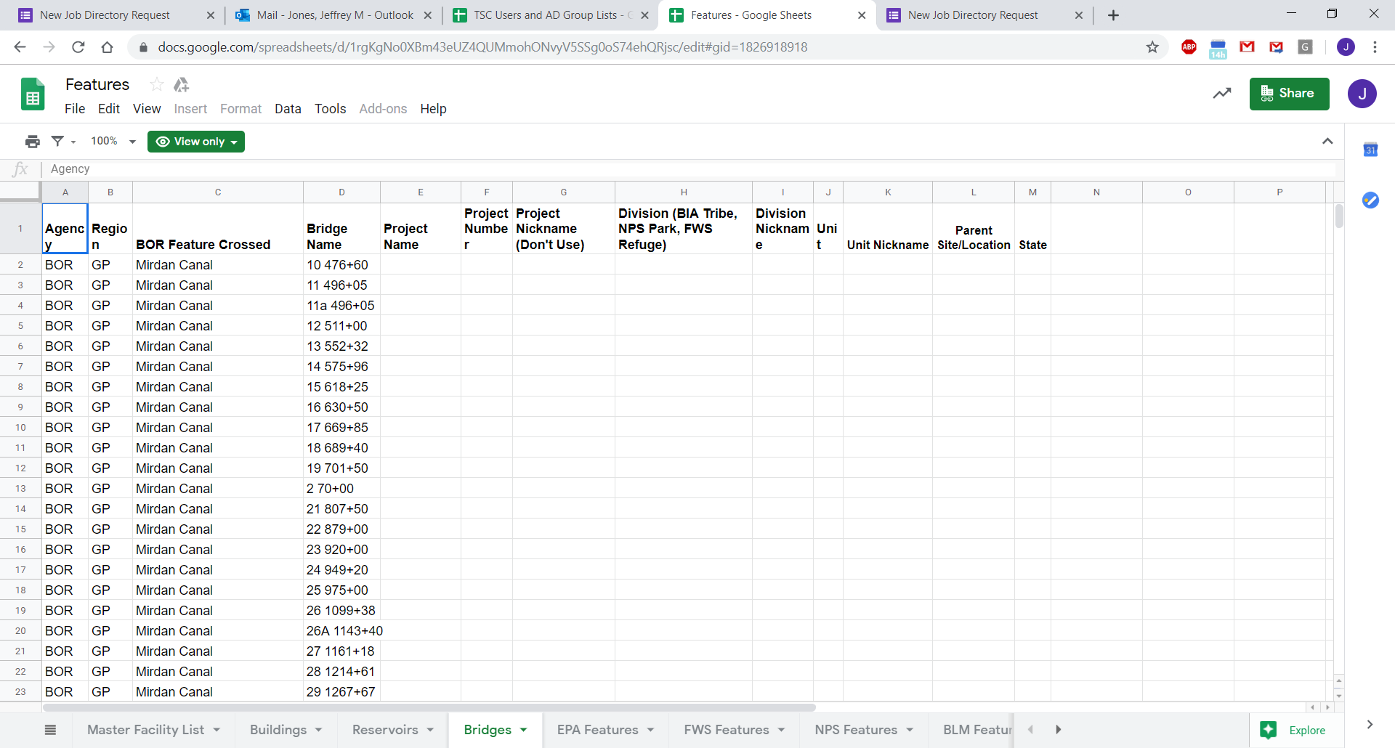

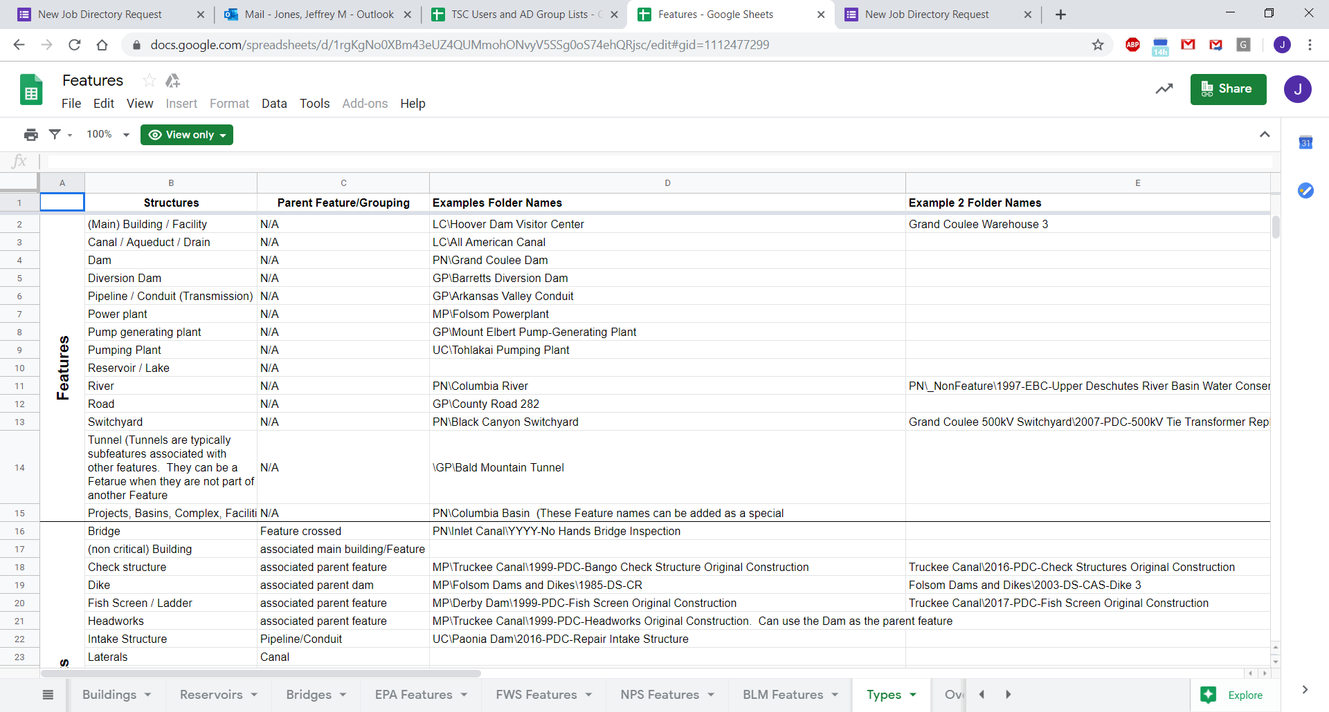

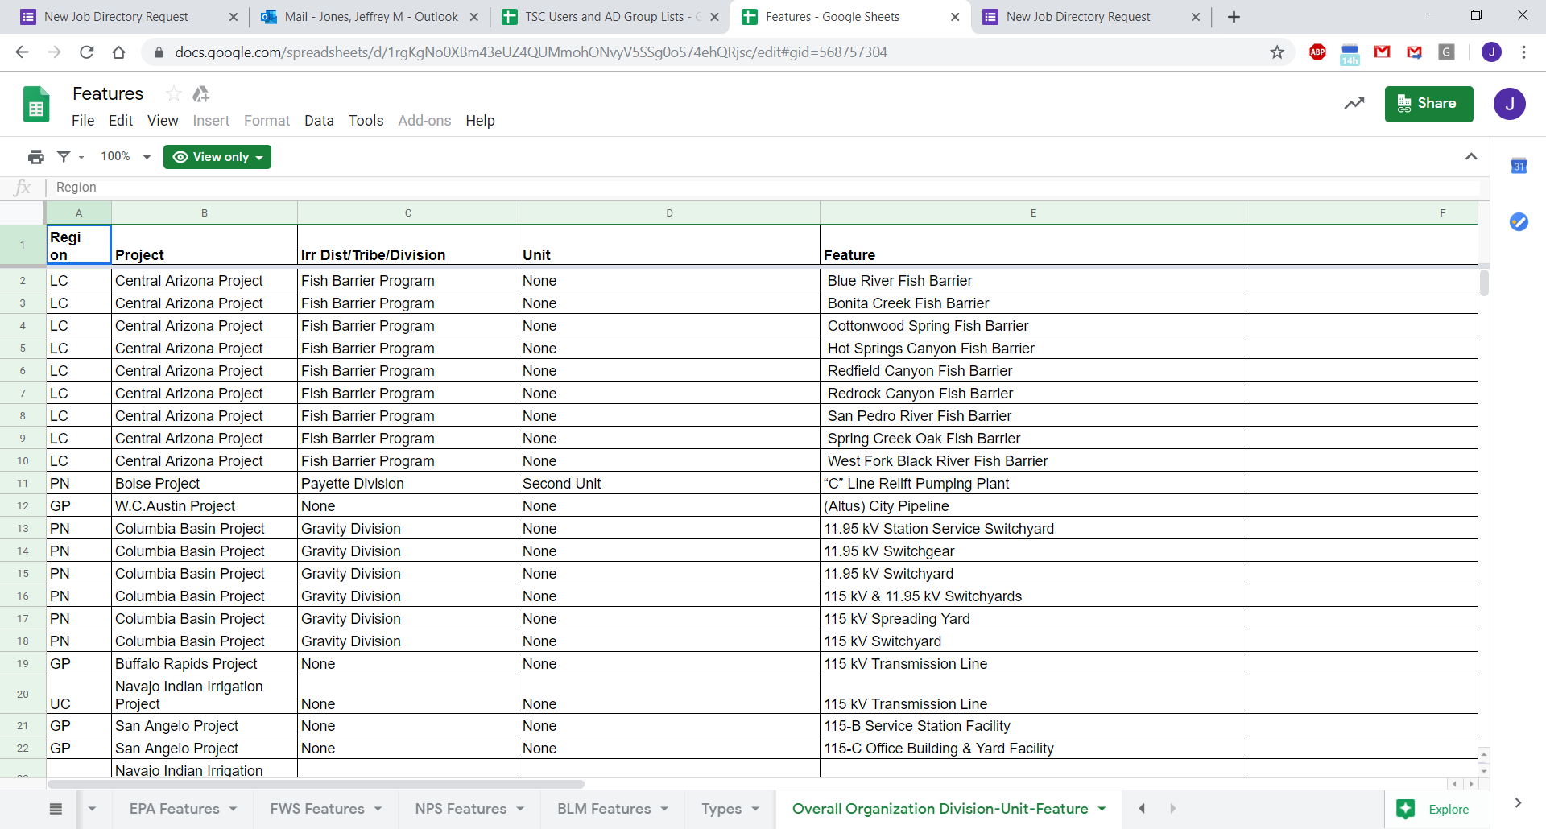Level of Effort

### Proposed solution:

[Rob’s initial take] The migration team proposes the use of an Excel spreadsheets to store the form responses. The form itself can be redeveloped using PowerApps to allow the most flexibility. The Excel spreadsheets can be used for tracking and executing workflow tasks with conditional formatting and color coding.

[Brian’s initial take] The migration team proposes the use of a SharePoint list to store the form responses. The form itself can be redeveloped using PowerApps to allow the most flexibility. The SharePoint list can be used for tracking and executing workflow tasks. If conditional formatting and color coding are needed on the list of form responses, some custom work may be necessary.

[Jeff’s recommendation] Data storage should be migrated from Sheets into SharePoint List with rows and columns to store user input. Lookup sources likewise should migrate from Sheets to SharePoint List. CSV External source is considered out of scope for any direct modification. However, CSV should be imported to SharePoint List with Microsoft Flow for each action steps. PowerApps can supply the primary form input interface with validation, search, multi-screen, and data connection features. MS Flow can provide email notification both during initial save and subsequent completion.

### Roles required:

* Transition Team
  + Project Manager – Rob Schnorr
    - [robert_schnorr@ibc.doi.gov](mailto:robert_schnorr@ibc.doi.gov)
    - [rschnorr@definitivelogic.com](mailto:rschnorr@definitivelogic.com)
  + 1 Developer - TBD
  + 1 Tester – Rob Schnorr
* DOI Team
  + Subject Matter Expert - KayLee Nelson
    - [kdnelson@usbr.gov](mailto:kdnelson@usbr.gov)
  + Tester - Deanna Morrell
    - [dmorrell@usbr.gov](mailto:dmorrell@usbr.gov)

### Effort and tasks:

|  |  |  |
| --- | --- | --- |
| Task | Roles Required | Dates |
| Initial Discovery Call | Transition PM  DOI SME | 09-09-2019 |
| Gather requirements | Transition PM  Transition Developer  DOI SME | 10/14-10/22 |
| Requirements signoff | Transition PM  DOI SME | 10/23-10/25 |
| Design | Jeff Jones | [Add Timeframes] |
| Build | Jeff Jones | [Add Timeframes] |
| Test | Transition PM  Transition Developer  Transition Tester  DOI SME  DOI Tester | [Add Timeframes] |
| Training/Communication | DOI SME | [Add Timeframes] |
| Deployment/Rollout | Transition PM  Transition Developer  DOI SME | [Add Timeframes] |

## Schedule Impacts

### Acceptable downtime:

The solution is most used with regular frequency and without noticeable season spikes. It is acceptable that the solution is down briefly during Q1. As a result, the script migration may take place after the Bureau drive and mail migration to Microsoft.

### Drive & Mail Migration Consideration

Due to Drive & Mail migration timing and outside factors, data associated with forms and scripts will be migrated as part of the Drive migration, but we cannot guarantee that scripts functionality will be recreated before Bureau migration is completed. This may result in data access only until the functionality is recreated with Microsoft products.

## Solution Sign – Off

This section documents milestones of the Script migration from Google to Microsoft.

### Requirements

The requirements was confirmed by Lee Jacobs on 10/25/2019.

### Testing

The solution was validated by Lee Jacobs on 12/18/2019

### Release

The solution was released by [Customer Name] on [Date].